- First to Arduino's official website to download IDE Arduino, and then installed to your computer, and then connected to the R3 board, computer equipment management which will appear unknown devices, need to install the driver.
2. In fact, Arduino driver is put into the compressed package, and its location in the directory you just installed IDE Arduino.
for example：D:\Program Files (x86)\Arduino\drivers
That is, your IDE Arduino installation directory under the drivers folder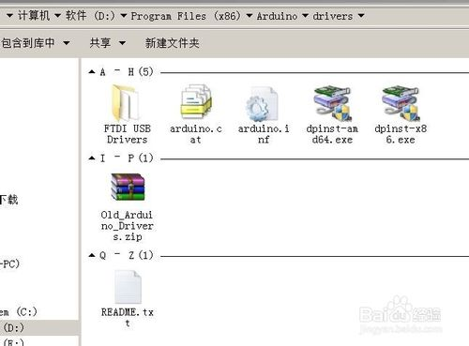
Decompression Name: Old_Arduino_Drivers compression package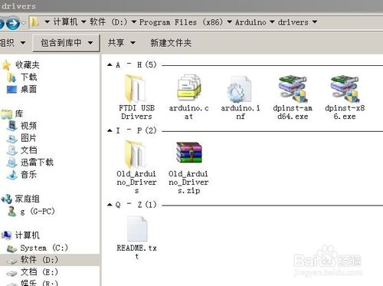
Into the Old_Arduino_Drivers folder, you will find that there are a lot of inf files, this is the Arduino controller driver, which UNO REV3.inf:Arduino, this file corresponds to the UNO R3 Arduino controller driver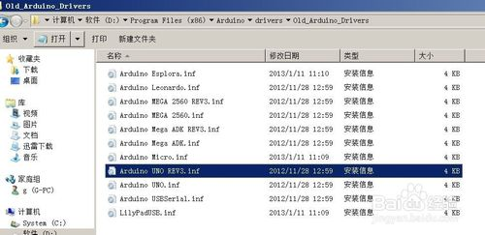
- The following official start UNO R3 Arduino driver installation process:
1.Just find the plug device with a yellow exclamation mark appears on Arduino UNO after R3 in Device Manager
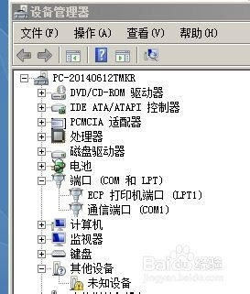
2.Update its program software
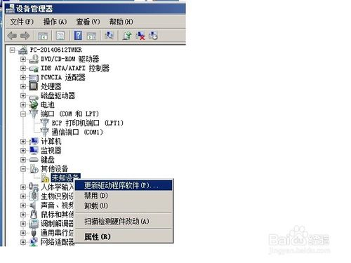
3.Browse the computer to find the driver software
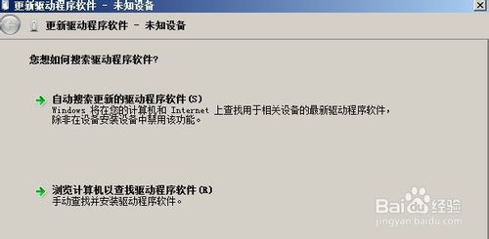
4.Search driver software in the following location
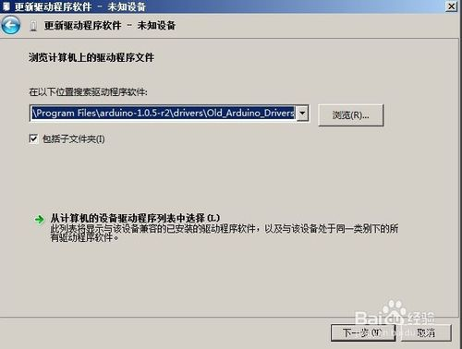
5.Always install the driver software
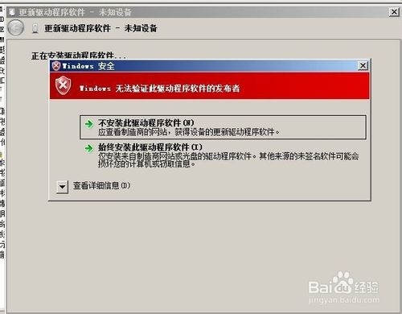
6.Windows has completed the UNO R3 Arduino driver installation
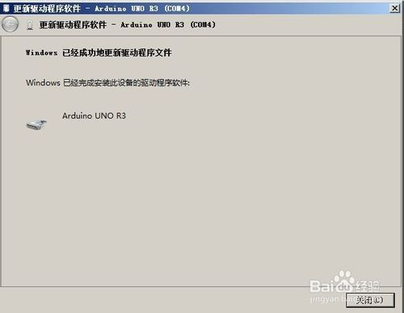步骤阅读
- 10
7.Completion of the UNO R3 Arduino driver installation, the device manager has emerged in the UNO R3 Arduino corresponding to the serial port.
